Table of Contents
Jupyter Notebook 1
Launching Jupyter Notebook 1
Creating a Jupyter Notebook 2
Saving the Jupyter Notebook 2
Working with Markdown 2
Running Cells of Code 3
Working with Python Code 3
Showing DataFrames as HTML 3
Showing Multiple Graphs on One Line 5
Showing Embedded HTML with Python 6
Exporting Output to PDF 7
Hiding the Code 7
Handling User Input in Juypter 8
Installing IPython and ipyidgets 9
TextBoxes and Buttons 9
BCIT Jupyter 10

Jupyter Notebook
As you may know already, Jupyter Notebook is a free tool which allows you to write, edit and run your Python application with content in between blocks of code. Markup can include text, graphics, and HTML. Jupyter Notebooks that are built to show code, markup and output can be updated to present the latest data with the click of a button. Because of this, Jupyter has become popular as a reporting and communications tool for data / technical analysts who are familiar with Python.

Example 4: Jupyter Basics
This example walks through the process of using Jupyter to format markup and code output.

Launching Jupyter Notebook
To launch Jupyter Notebook, open the Anaconda Navigator from either the Start menu on Windows or the Application area on a Mac.

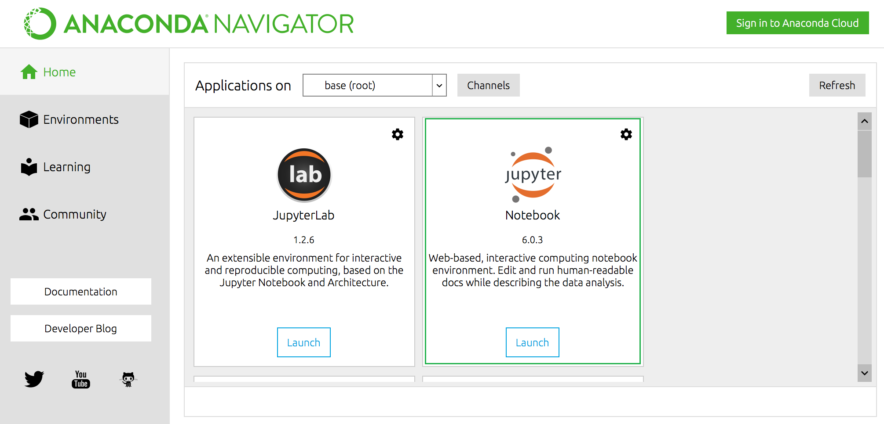

Creating a Jupyter Notebook
Before you create a notebook, navigate to a folder that you can find easily. Then from the File menu choose New | Notebook.

Saving the Jupyter Notebook
To save the Jupyter Notebook, from the File menu choose Save Notebook As. Leave the original folder path but add yourfilename.ipynb and click Save. Your code will be saved in a *.ipynb file at the specified location.
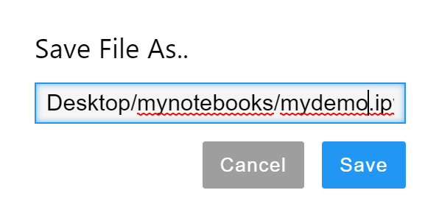

Working with Markdown
Markdown allows you to enter text and HTML. You can use Markdown to format and present your documentation to compliment both your code and the output from the application. To add some markdown, from the Insert menu add a cell. Then select the markdown option.
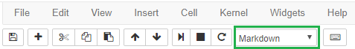
After, place the following code inside the cell:
# Markdown titles are created by starting the line with a hash symbol.

The following title uses HTML which you can also include in your markdown.
<h3>This is Another Title</h3>
This image is loaded using HTML.<br />
<!-- This image exists in the Jupyter notebook root folder.
On my Windows machine this happens to be at c:/users/username/
You can also store the image there if you upload it at the
Jupyter Notebook tree listing. -->

<img style="float: left;" src="https://commons.bcit.ca/news/files/2020/05/Island-Princess_1200px-300x150.jpg" />

On examining the markdown, you can see how a title, html and images can be added in the markup.

Running Cells of Code
When your cursor is in the cell while Markdown is selected, if you either select Cells | Run Cells or you press ctrl + Enter the markup will display in its presentation format:
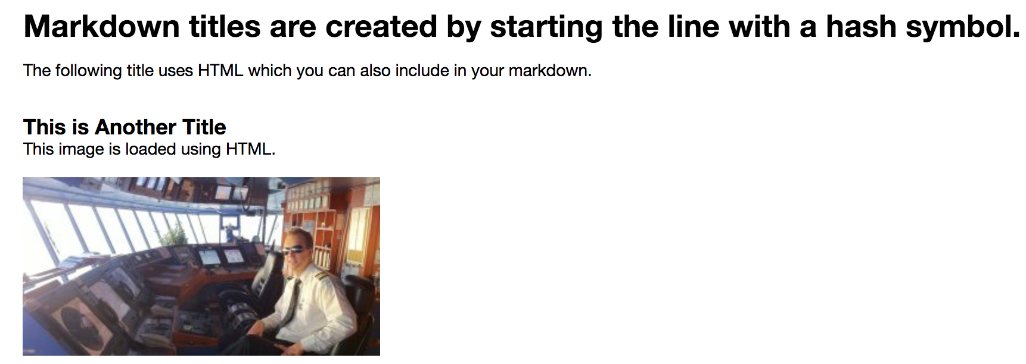
To go back and edit the markup, select Raw NBConvert.

Working with Python Code
Obviously, we really want to use Jupyter to edit and run our code. This section shows how to edit and run our Python code with some extra information on how we can format our output beyond the usual print() statements. To enable the code editor, select Insert | Insert Cell Below. Make sure the Code option is selected for that cell.

Showing DataFrames as HTML
You can run a regular print() function to display a data frame in Jupyter Notebook and this will work well. However, you can convert a data frame to HTML to display it for much nicer results with these two instructions.

html_str = df.to_html()
display_html(html_str.replace('table','table style="display:inline;"'),raw=True)

Example 1: Showing DataFrames as HTML
This example compares standard and html versions of a data frame. The work needed to format the output is negligible.
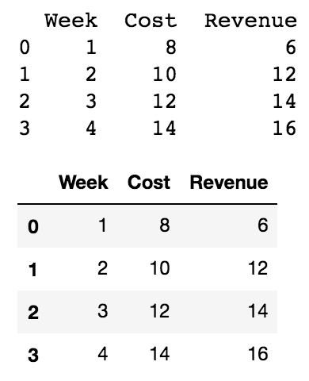
# import matplotlib.pyplot as plt
import pandas as pd
from IPython.display import Image
from IPython.display import display_html
from IPython.core.display import display, HTML
import matplotlib.pyplot as plt

def display_side_by_side(*args):
html_str=''
for item in args:
html_str+=item.to_html()
display_html(html_str.replace('table','table style="display:inline;"'),raw=True)

# Create and show budget dataframe.
df = pd.DataFrame(columns=["Week", "Cost", "Revenue"])
df['Week'] = ['1','2','3','4']
df['Cost'] = [8,10,12,14]
df['Revenue'] = [6,12,14,16]
print(df)
#display_side_by_side(df,df)
html_str = df.to_html()
display_html(html_str.replace('table','table style="display:inline;"'),raw=True)

Example 2: Showing DataFrames Side by Side
Sometimes you may want to display your data frames in one row so this section shows how you can with HTML. When running the program, the dataframe output is generated with the following code:
def display_side_by_side(*args):
html_str=''
for item in args:
html_str+=item.to_html()
display_html(html_str.replace('table','table style="display:inline;"'),raw=True)

display_side_by_side(df,df)

To run this code, select Cell | Run Cells. The output first displays a raw data frame with the usual print() command. Next a pair of HTML data frames are displayed on the same row:
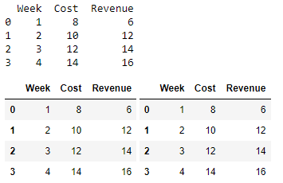

Showing Multiple Graphs on One Line
You may at times want to display more than one graph on a line. To do this, add a new cell and place this code inside it.

Example 3: Showing Multiple Graphs on One Line
This uses the subplot() feature to set the number of graphs per row. The figsize property allows us to adjust the width and height of the graphs.
# First chart.
plt.figure(figsize=(6,1.3))
plt.subplot(1, 2, 1) # 1 row. Two columns. 1st cell.
plt.plot(df['Week'], df['Cost'], color='red')
plt.ylim((6,16))

# Second chart.
plt.subplot(1, 2, 2) # 1 row. Two columns. 2nd cell.
plt.plot(df['Week'], df['Revenue'], color='green')
plt.ylim((6,16))

# Show plots.
plt.show()

While your cursor is in the current code cell, press ctrl + Enter to run this block of code. Running the code displays two graphs side by side:
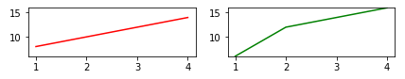

Showing Embedded HTML with Python
For more formatting flexibility, you may wish to present additional content in Python with embedded HTML. HTML can be displayed in your Jupyter output with the HTML and display function:

display(HTML("<h4>This is html code.</h4>"))

Example 4: Embedding HTML
To see how to embed HTML embedding is done, upload an image to your Python folder.
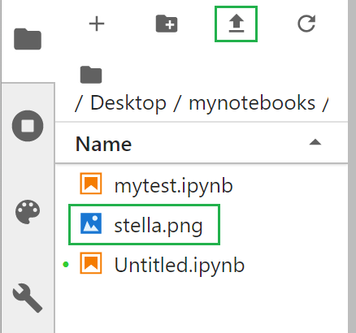

Then add a new cell and place this code in it:
# We can use display() to show HTML from Python.
# HTML() converts encoded content the raw content.
display(HTML("<h4>This text and image are rendered using html embedded in Python code.</h4>"))

# This image is stored at the Jupyter notebook root folder.
img=Image(url= "files/stella.png")
display(img)

When you run this cell, the following content is presented:
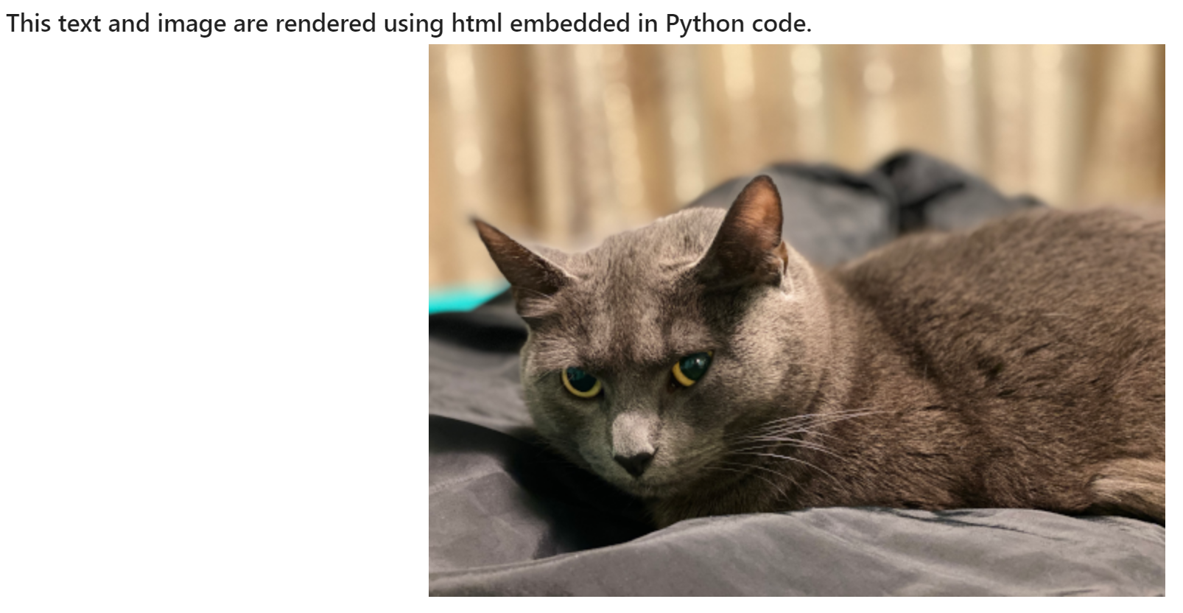

Exporting Output to PDF
I have had mixed results while exporting output from Jupyter Notebook. There are several options but each one does not perfectly replicate the display from the actual Notebook. My best results, without much effort, have been obtained by exporting directly to pdf from Notebook’s File | Print menu. Depending on the version of Jupyter that you are using, you may use Chrome’s print menu and then export to pdf when prompted.

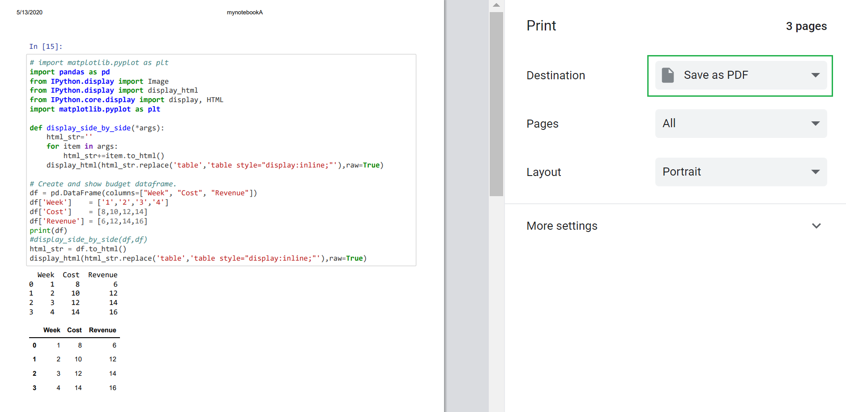
The results are decent:
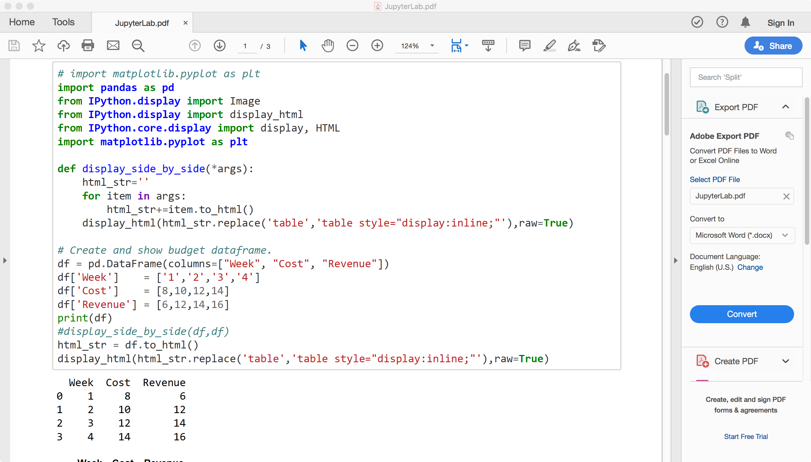

Hiding the Code
If you want to hide the code and only show the markup and code output you can.
Example 5: Showing and Hiding Code
Adding this to a code cell will generate a button which allows you to toggle between displays with and without code.
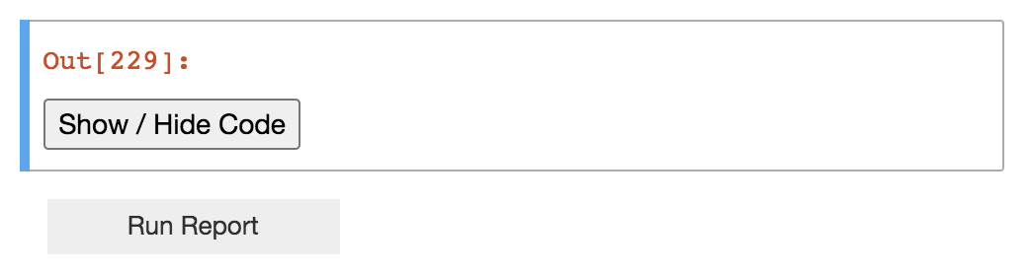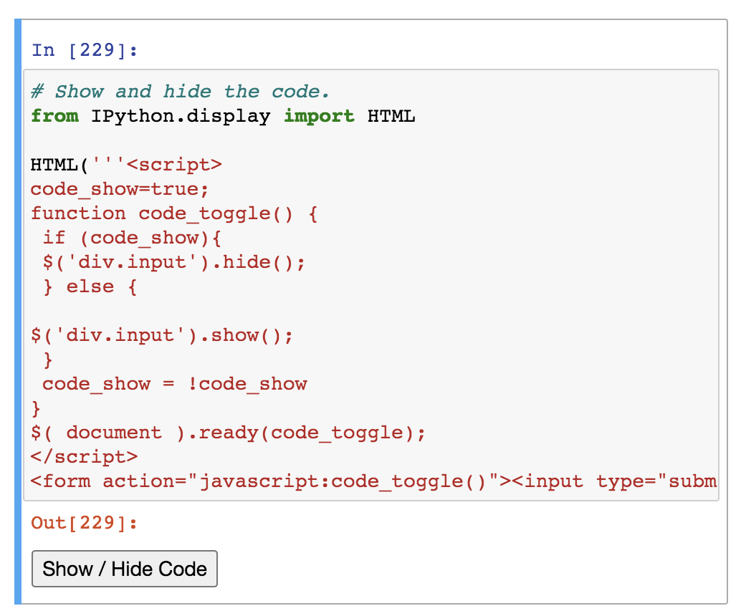

from IPython.display import HTML

HTML('''<script>
code_show=true;
function code_toggle() {
if (code_show){
$('div.input').hide();
} else {
$('div.input').show();
}
code_show = !code_show
}
$( document ).ready(code_toggle);
</script>
<form action="javascript:code_toggle()"><input type="submit" value="Click here to toggle on/off the raw code."></form>''')

Handling User Input in Juypter
Jupyter is recognized as being a popular tool for technical reports since it is possible to mix code and output together. It is also possible to use Jupyter to develop dynamic reports for non-technical users.

The ipywidgets library provides controls like text boxes, buttons, drop downs, date pickers, checkboxes, radio button lists and more. These controls enable an interactive experience. A listing of controls can be found at https://ipywidgets.readthedocs.io/en/stable/examples/Widget%20List.html

I find this collection of controls to be awkward to work with but there is enough present to handle most data reporting situations with some creativity. The documentation is fair but, in my opinion, it is also lacking. If this set of controls interests you I recommend taking simple steps to work with them at first until you gain confidence and more understanding around how they work.

Installing IPython and ipyidgets
To install these control libraries, Windows users can run these commands in the Anaconda prompt which can be opened at the start menu. Mac users can run these commands in the terminal.

conda install IPython
conda install ipywidgets

TextBoxes and Buttons

Example 6: TextBox and Button Combination
This example shows a text box and button combination. When content is entered into a text box and a button is clicked after, the contents of the text box are printed on the screen.

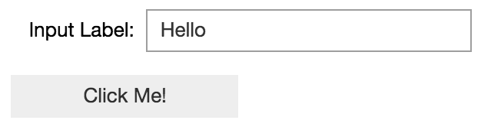

Details about how the code works and where it needs to be placed are explained in the comments. Notice how a text box must be declared before it is shown. The text box is shown with the display() function.
from IPython.display import display
from ipywidgets import widgets
from IPython.display import clear_output

# Define and show text box.
txtInput = widgets.Text(
value = '',
placeholder = 'Input placeholder',
description = 'Input Label:',
disabled = False
)
# Use the display() function to show the text box.
display(txtInput)

# Define and show button.
from IPython.display import display
button = widgets.Button(description="Click Me!")

# Use the display() function to show the button.
display(button)

# This handles the button click event.
# We must include the ‘e’ parameter with event functions to ensure
# that we can call them when desired in web frameworks.
def on_button_clicked(e):
# Clear output to prevent incrementing lines of output.
clear_output()
print(txtInput.value)

# Create a listener for the button click event. This listener belongs after
# the handler named on_button_clicked() for the event is defined.
button.on_click(on_button_clicked)

BCIT Jupyter
As a BCIT student you are eligible to use an online version of Jupyter
https://bcit.syzygy.ca/

